

Practical No: 3

Date: 5th October 2026

Title: Sampling, Quantisation and DAC Reconstruction

Name: Joe Blogs

Course: Bachelor of Engineering in Electronic Engineering

Subject: Digital Communications and Transmission

Lecturer: Ben Graham

Summary:

This practical investigates the design and implementation of a 4-bit Pulse Code Modulation system using an MSP430 microcontroller.

Objective:

El objetivo principal de esta práctica fue diseñar e implementar un sistema de Modulación por Impulsos Codificados (PCM) de 4 bits para digitalizar una onda senoidal y reconstruirla mediante un circuito amplificador sumador discreto. Este proceso permitió consolidar los fundamentos teóricos mediante la implementación práctica de rutinas de muestreo utilizando los temporizadores por hardware del microcontrolador MSP430. Asimismo, se ejecutó la cuantización y codificación binaria al mapear y reducir los datos originales de 10 bits del ADC hacia una salida paralela de 4 bits. Finalmente, a partir de estos datos digitales, se logró reconstruir la señal analógica original y se evaluaron las limitaciones inherentes del sistema, tales como el ruido de cuantización, las restricciones en el escalado de voltajes y la distorsión generada por el efecto de aliasing.

Theory:
El proceso de Modulación por Impulsos Codificados (PCM) consta de tres etapas fundamentales: muestreo (Sampling), cuantización (Quantisation) y codificación (Encoding). En este laboratorio, el temporizador por hardware se configuró para que el ADC muestreara la señal analógica a una frecuencia exacta de 20 Hz. Posteriormente, la resolución original de 10 bits generada por el ADC se redujo a 4 bits mediante operaciones de código, logrando así la cuantización de la señal en 16 niveles discretos y su codificación para la salida paralela.

Equipment Used:
Signal Generator – MP750510
Oscilloscope –
MSPG2553 Development Board
741 Op-Amp
Resistors:
- 5k resistors (1)
- 10k resistors (4)
- 20k resistor (1)
- 40k resistors (1)
- 80k resistors (1)

Analogue Input Generation

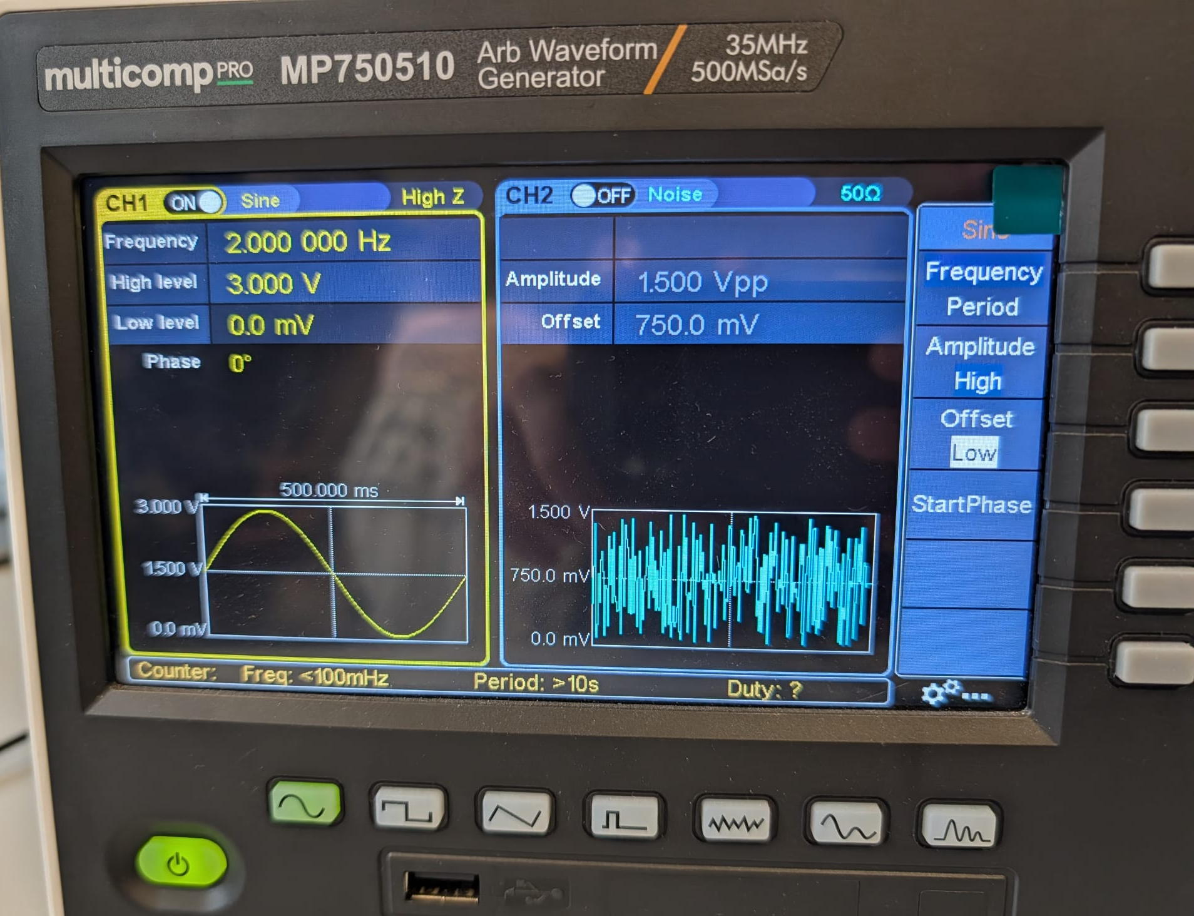
Figure 1: Configured wave

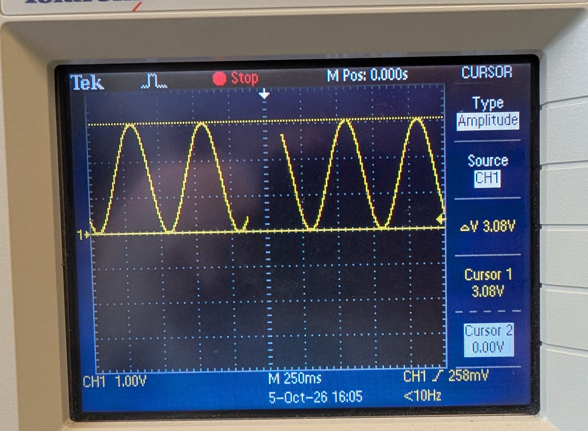
Figure 2: Waveform verified in the Oscilloscope

Hardware Configuration & Sampling Routine
During this phase of the practice, the necessary hardware configuration and sampling routines were established to process the generated signal.
Initially, the microcontroller's pins P1.0, P1.1, P1.2, and P1.3 were configured as outputs, while pin P1.4 was exclusively designated as the input for the ADC. This setup allows the digital data to be transmitted in a 4-bit parallel form. Furthermore, the 10-bit ADC was initialized and configured to accurately capture the incoming analogue signal on pin P1.4.
Finally, the internal hardware, Timer A, was configured to establish a precise sampling rate of 20 Hz.

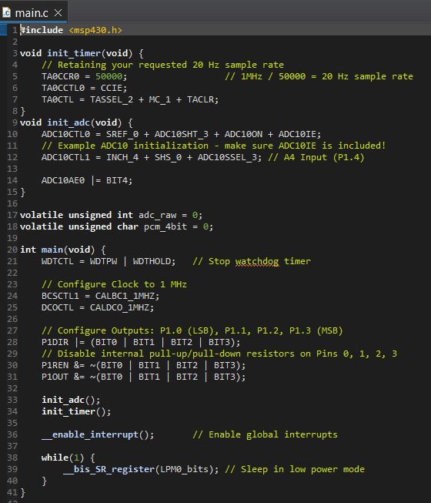
Figure 3: Code in Code Composer Studio

Quantization and Encoding of the signal:

Using the code described in the previous paragraph, different voltages (0, 1, 2, and 3 V) were tested, thereby verifying that the theoretical values calculated in Figure 4 were correct. For this purpose, the signal from the signal generator was connected to pin P1.4 of the MSP430. Once processed, the microcontroller outputs the corresponding numerical value in binary through pins P1.0 - P1.3, with P1.0 being the LSB and P1.3 the MSB. One final interesting detail learned during this part of the practical is that using the MP750510 signal generator does not yield consistent results due to how this device operates, as its signal is not constant. On the other hand, the EL302Tv signal generator did allow for generating the signal correctly, as it generates a constant signal.

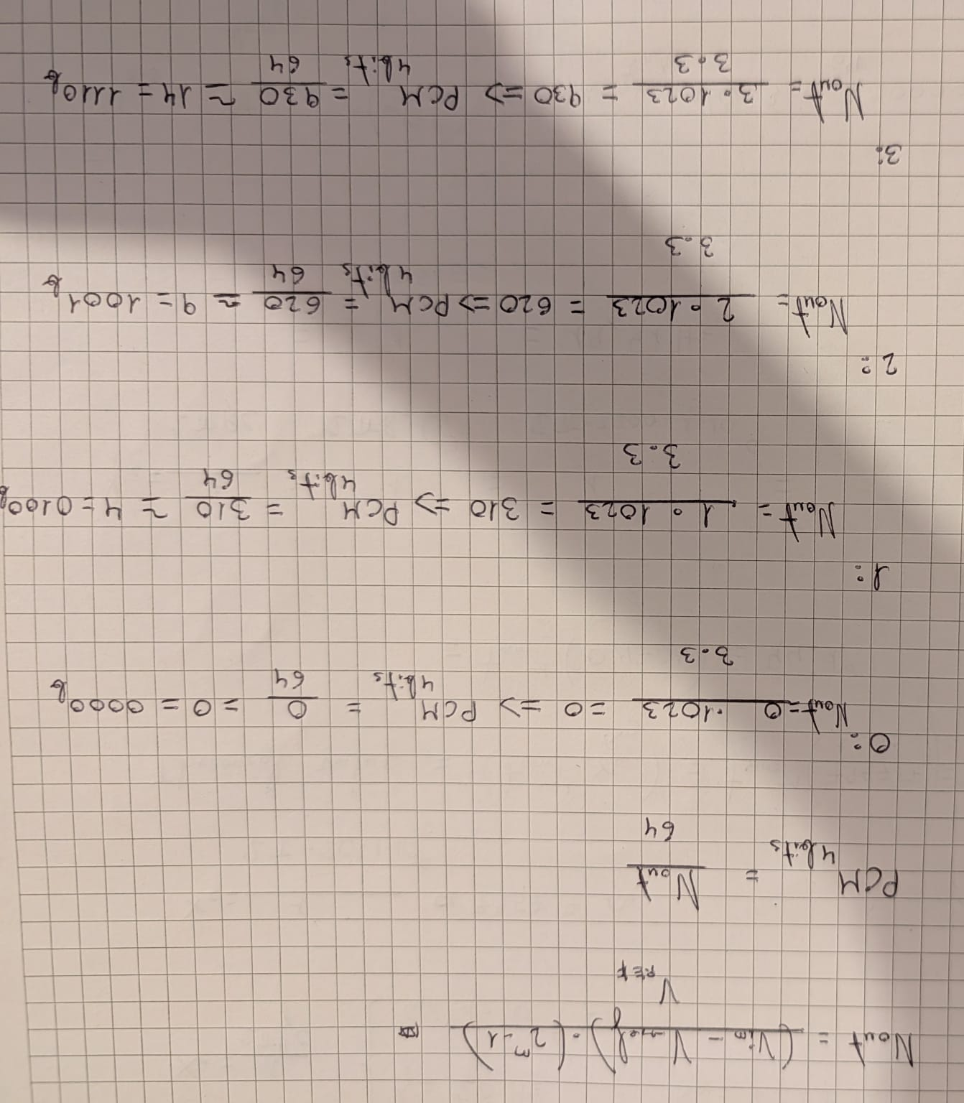
Figure 4: Calculation of theorical values
To sum up:
0V: 0000
1V: 0100
2V: 1001
3V: 1110

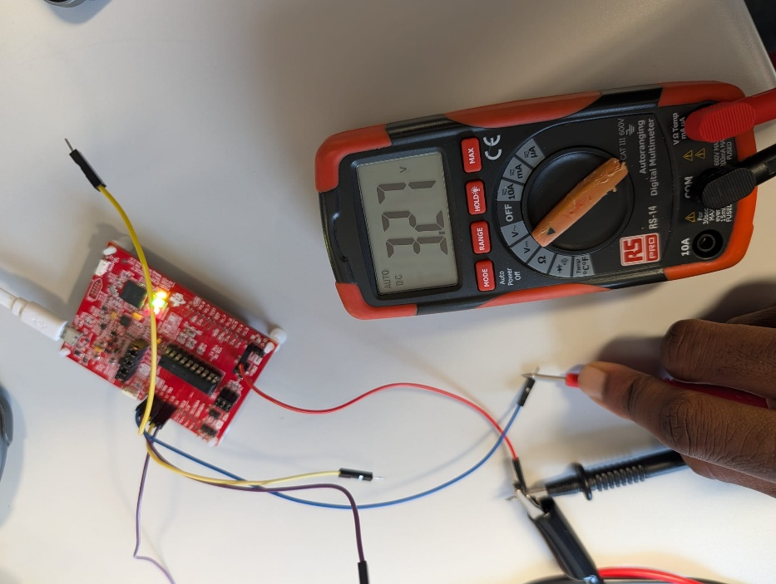
Figure 5: Measure of P1.0 with 3.3V in P1.4

Discrete DAC Hardware Reconstruction
The final phase of the practical involved converting the digital signal back into an analogue waveform that resembled the original input. To achieve this Digital-to-Analogue Conversion (DAC), a 4-channel summing amplifier circuit was constructed on a breadboard.

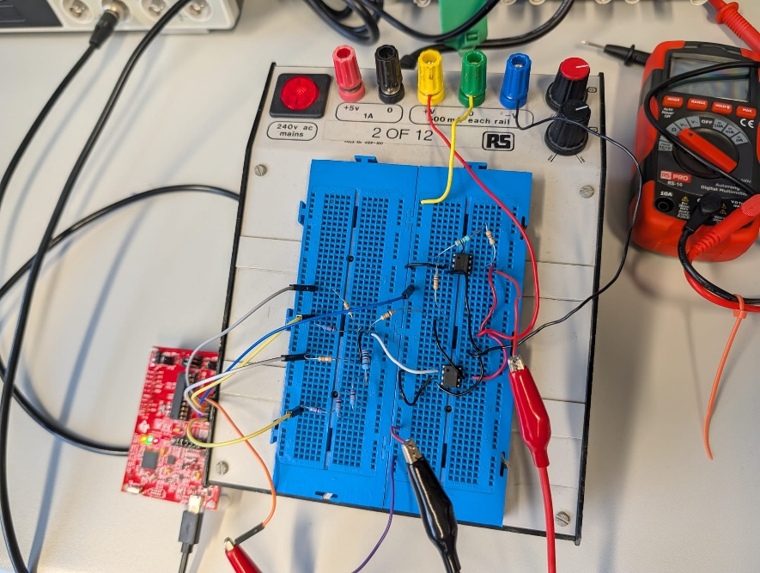
Figure 6: Summing Amplifier
La fase final de la práctica consistió en convertir la señal digital de vuelta a una forma de onda analógica que se asemejara a la entrada original. Para lograr esta conversión digital a analógica (DAC), se construyó un circuito amplificador sumador de 4 canales utilizando operacionales UA741 en una protoboard. Durante la fase de pruebas, la señal analógica reconstruida se capturó con el osciloscopio (ver Figura 7). La onda resultante mostró el esperado efecto de cuantización en forma de escalera, validando el principio fundamental de la conversión. Sin embargo, la señal no exhibió los 16 niveles discretos de voltaje que corresponden a la resolución de 4 bits del sistema. En su lugar, se observó una forma de onda con escalones significativamente más grandes y una menor cantidad total de niveles. Esta limitación se atribuye a dos posibles fuentes de error experimentales, una amplitud insuficiente en la señal analógica de entrada que no logró abarcar el rango dinámico completo de 0 a 3V del ADC, o un fallo de conexión física en la protoboard (como un mal contacto en el pin del bit menos significativo, LSB), lo cual habría forzado al DAC a operar con una resolución efectiva inferior, similar a un sistema de 3 bits u 8 niveles.

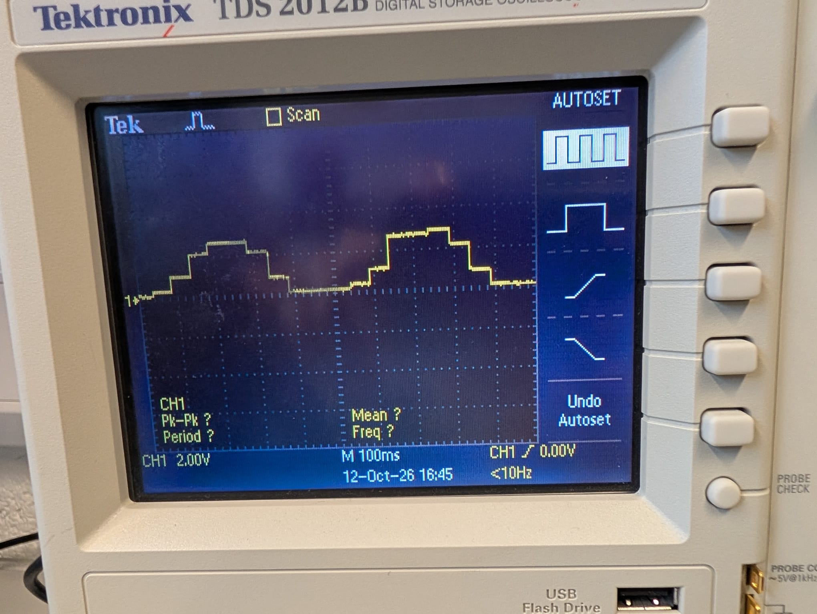
Figure 7: Reconstructed Signal
PARTE 4. DIBUJAR COMO SE VERIA CON LOS 16 NIVELES. Y EXPLICAR QUE LA RAZON PRINICIPAL POR LA QUE NO FUNCIONA ES POR UN MAL CABLEADO DENTRO DE LA BREADBOARD

5. Analysis and Questions

Question 1: What would the output be for binary value of 1,1,1,1

Procedure & Results:

- Validation Check: Apply fixed DC test voltages (0V, 1V, 2V and 3V) to pin P1.4. Measure pins P1.0 through P1.3 with a multimeter or digital oscilloscope to verify that the binary outputs track perfectly with your expected values.

Explain the steps you have taken throughout the lab, answer any questions. Discuss and explain your findings. Include images, oscilloscope screenshot and graphs to verify the results.

Ensure all images are clear and cropped correctly
Label graphs and include a figure number under all images and plots.
Use cursors on oscilloscope to highlight any important measurements

Figure 1 – Analogue Signal Plot

Conclusion:

Explain your results any errors, sources of improvements, any points of interest during the lab.
Laboratory Report Guidelines

The objective of a laboratory report is to communicate the details of a piece of work to a third party, in such a way that should they wish, they could repeat and verify your work. It is the task of the report writer to structure the information into a format appropriate to the target audience. The previous pages are a useful guide to the structure of a formal technical report. Report should be submitted in both word and pdf versions.

Page1

Lab Number
Date
Title (not more than 2 lines)
Name
Course
Subject
Lecturer
Summary (not more than 3 lines saying what the lab is about)

(See example sheet)

Page 2

Objective: The aim of the experiment.
Equipment used: A description of any equipment/components used.
Theory: A brief explanation of background principles on which the lab is based.
Procedure: Step by step explanation of how the experiment was carried out, past tense.
Results: Data, tables or computer printout, graphs etc, show all calculations, final outcomes, percentage errors etc.
Ensure any oscilloscope images are maximum to fill the oscilloscope screen, use markers/cursors on oscilloscope when presenting measurements.
Oscilloscope screenshots can be saved to USB pen drive or a picture taken with phone. Any photo screenshots should be straight, clear and cropped appropriately to show only the oscilloscope screen. Use cursors on oscilloscope to take measurements..

Last page
Conclusion: In your own words why what happened, what you have seen or proven, reasons for success or failure, suggestions for improvement, sources of errors etc.

Digital Communications and Transmission Lab Report Marking Rubric

Standards | > 80% | 65% – 80% | 40 – 65% | < 40% Fail
General Report Layout  (Weight: 10%) | Follows the formal report template structure. Third – person used throughout. | Clear progression through all sections of the draft report. Minor errors, referencing, etc. | Mixes third- person and first. Presentation and structure is inconsistent. Some grammatical or formatting errors. | Hard to follow, fails to follow the report structure. Incomplete, fails to meet basic academic/technical standards.
Procedure / Methodology  (Weight: 30%) | Clear, concise summary of the procedure and methodology. Possible used schematics and images to explain, perfect labelling. In depth knowledge presented | Covers the main steps and setup accurately. Minor details or omissions from diagrams, etc. | Simply copied the lab sheet text without showing personal understanding. | Omits critical steps/sections, unrecognizable, missing entirely.
Data Presentation & Accuracy  (Weight: 30%) | All data presented in a clear and clean manner. Images cropped with image reference used. Correct units used, clear axes, titles used on graphs. Any references included. | Data is accurate and structured. Minor incorrections in units, labelling, axis, etc. | Data is present but disorganized. Units missing, visually poorly presented. Minor calculations error. | Calculations wrong, fabricated data, completely missing data. Unacceptable level of data presented.
Discussion & Error Analysis  (Weight: 30%) | Deep evaluation provided between experimental and data. Clear understanding of sources of error, measurement uncertainties or equipment tolerances. Deep knowledge of the subject. | Correctly compares results to theoretical values. Identifies errors but doesn’t present critical insight.  Knowledge of the subject. | Notes any gaps between theory and results, without discussion or simply blamed as human errors.  Limited knowledge of the subject | No interpretation or engineering context.  No discussion

